
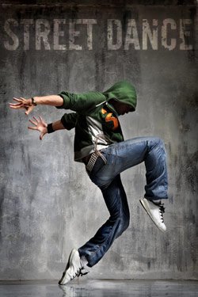
FROM SATURDAY MAY 10TH WE WILL BE RUNNING STREET DANCE CLASSES AT THE CALLYWITH CENTRE IN BODMIN

9.00-10.00 STREET DANCE 8 YEARS AND UP
10.00-11.00 STEEET DANCE 5-8 YEARS
ONLY £4.50 PER CLASS

To book a place contact us on 01872 276365

The classes are held at Callywith Centre, Bodmin

